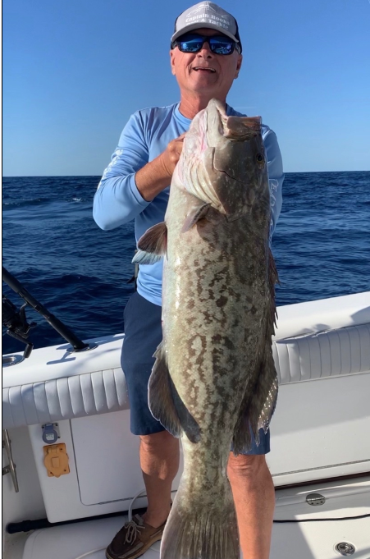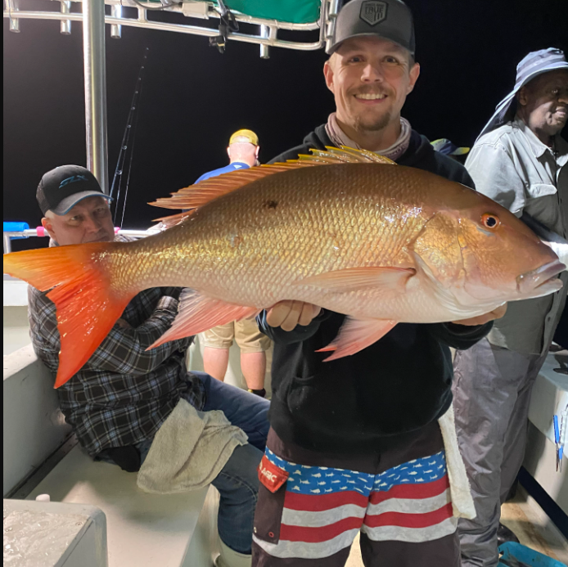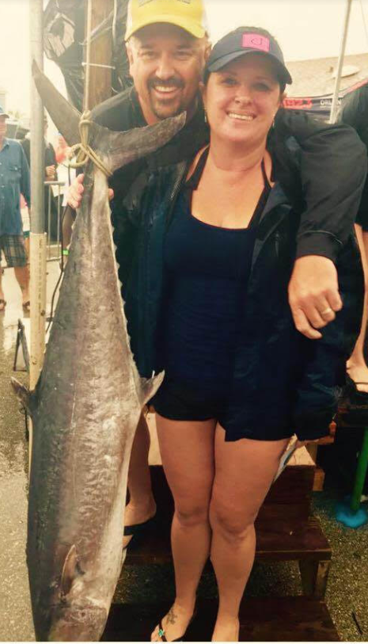
General Meeting: Tuesday, February 7th
Where: Front Street Civic Center, 2205 Front St, Melbourne, FL 32901
Time: Social Time: 6:30 pm and Meeting Starts at 7:00 pm
Guest Speaker: Grand Master Symposium (Homemade spagehetti dinner served with donation)
Dave Robb (School Bass, Sunshine’s, Shad and Threadfin, the way they're all connected. Bonus large channel cat secrets)
Mark Wilson (How to read the tides to target Bahamas Bonefish & Bahamas Wahoo)
Ryan Vetsch (Bottom fishing for mangrove and mutton snappers)
Chris Pashos (Slow Pitch Jigging secrets)
Chris Delaney (Kingfish Secrets from the Salty Champ)
Ron Rincones (Cobia Secrets from a lifetime of fishing)
