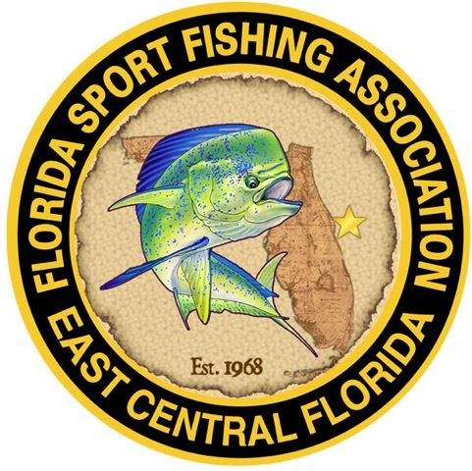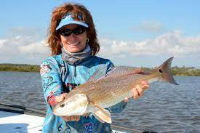
Raffle Prize will be tailored to our lady anglers
General Meeting Tuesday, February 28th

Where: Veterans Memorial Center, 400 S Sykes Creek Pkwy, Merritt Island, FL
Time: Social Time: 6:30 pm and Meeting Starts at 7:00 pm
Guest Speaker: Leiza Fitzgerald
In her 30-year outdoor career, Captain Leiza Fitzgerald has been instrumental in introducing women to the sport of fishing. She has helped create and implement some of the sport’s most iconic events. Her professional team, “Screamin Reels N High Heels”, was ranked a Top-10 Florida team earning a spot in the Southern Kingfish Association’s National Championships in 1998. Her two-woman redfish team was ranked as one of the Top-10 ESPN “ALL STAR” Redfish Teams in the country. In 2018, she was listed by Salt Strong as one of the top 12 lady anglers in Florida. In 2019, Leiza was named Sportsman of the Year by The Sarasota Sportsman’s Association, the first time a woman had been named. In 2020, she was named as one of the 30 most influential female anglers (Top 5 in Saltwater) by Wildlife Enthusiast magazine. She won Annual Top Angler for Redfish from the International Women’s Fishing Association (IWFA) in 2020 and retained her status in 2021 when she won IWFA Annual Top Angler for Redfish, Snook and Sheepshead. Leiza has affectionately been deemed “Queen of Conservation” for her tireless efforts to help improve marine fisheries. Content: Provide by Florida Sports Hall of Fame

Leiza will be sharing her experience as a Florida fishing guide, telling her favorite fishing stories, and offering tips and suggestions for more productive saltwater fishing in East Central Florida. She will also talk about the Florida Star event that starts May 27th, 2023 and runs through September 4th, 2023 with over $500,000 in available prizes. Leiza will discuss the Youth Scholarship Division, which the FSFA was proud to sponsor this year, donating a $5,000 scholarship for award to one of our local youth division winners. Leiza will also be sharing information on the local ecosystem and efforts the CCA is making to help revitalize the area, as well as the efforts to support our offshore reef efforts.

